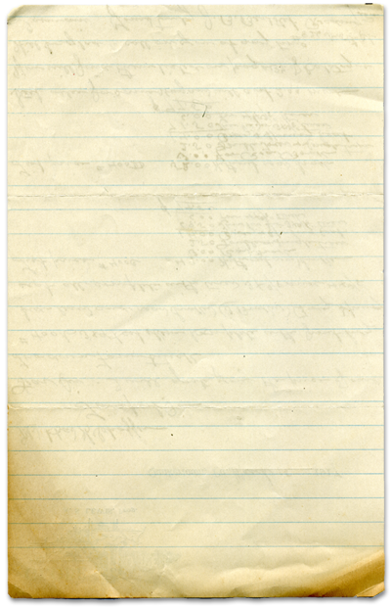

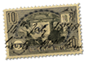

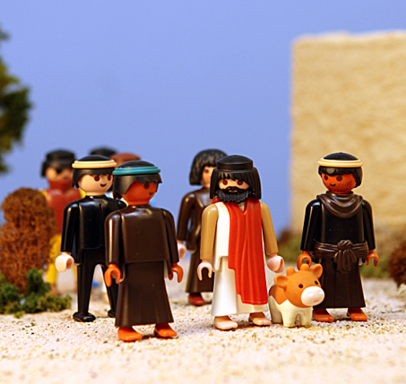



I can be a friend of Jesus.

Jesus calls Matthew, Friend

A friend of jesus
We all know people who love to name drop. I knew a woman who loved to impress others by naming the famous people she’d met at a party or met with at different conferences. My wife will tell you that I’m an absolute ignoramus when it comes to famous person name recognition. So, although this woman tried to impress me with her name dropping, I didn’t know anyone she was talking about. And, frankly, I didn’t care.
A couple of times I’ve introduced myself as a friend of someone. On those occasions I was afforded instant respect. That’s because the friend of mine had great integrity. I was respected instantly because of the friend I had.
Wouldn’t it be great if I walked into Costco and announced, “My name is Scott. I’m a friend of Jesus.” What would folks do? Call the police? A social worker? Would they be impressed? That’s something to think about.
Well, I am a friend of Jesus. And he calls me his friend, too. It won’t get me through Costco any faster but that’s not the point. The creator of the universe is my close, personal friend. I hope he’s yours, too.
You will find today’s story in

Matthew 9:9-13
Take It Home


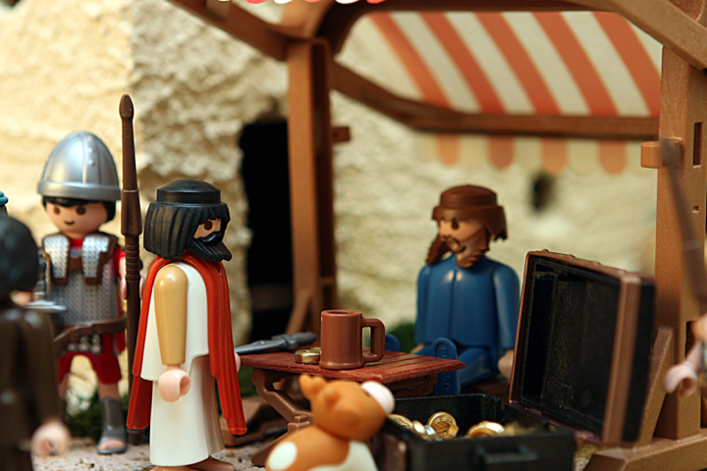



Please read this Bible story with your children. The questions you see below are the same ones we asked them in their small group time this week. We gave you the answers to help you out. Don’t treat this like a test, but make it a discussion. Ask more questions and get your children to tell you the story if they can.

The Call of Matthew
Matthew 9:9-13
I can be a friend of Jesus.

What was Sven today? A drill sergeant Was Sven a good drill sergeant or a bad drill sergeant?

What was Ole today? A private in the army Was Ole a good private or a bad private?

Why did Ole have problems today? He didn’t know his left from his right Have you ever had that problem?

What was the Bible story today? The story where Jesus asks Matthew to become his follower.

What was Matthew asked to do? Leave his job and follow Jesus. Did he do it? Yes Why? Because he trusted Jesus

Do you think Matthew got in trouble for leaving his job? Yes Do you think he cared? No. He wanted to do what Jesus wanted him to do no matter what happened.

Have you ever been asked to do something and you didn’t understand why? Did you do it? Why? We will often times do things we don’t understand if we trust the person who asked us to do them.

Do you think God likes it when we do what he tells us to do? Yes Why? It shows we trust Him.

Prayer: Ask God to help us trust him enough to believe in him and do what he says.
Today we thought we’d give you some random information. We hope you enjoy these useless but interesting facts.

If you have 3 quarters, 4 dimes, and 4 pennies, you have $1.19. You also have the largest amount of money in coins without being able to make change for a dollar.

The numbers '172' can be found on the back of the U.S. $5 dollar bill in the bushes at the base of the Lincoln Memorial.

President Kennedy was the fastest random speaker in the world with upwards of 350 words per minute.

In the average lifetime, a person will walk the equivalent of 5 times around the equator.

Odontophobia is the fear of teeth.

The 57 on Heinz ketchup bottles represents the number of varieties of pickles the company once had.

Every year 98% of the atoms in your body are replaced.
Interesting Facts

