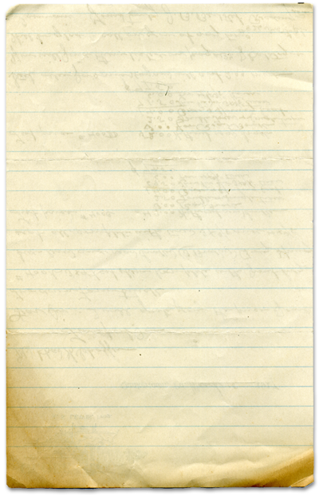



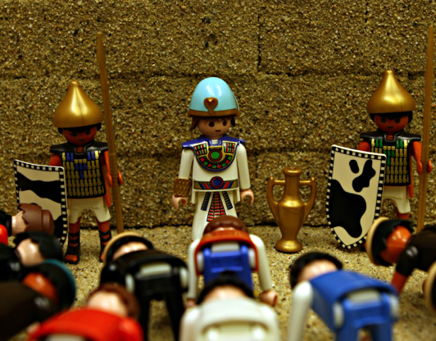



Joseph’s Reunion

God works all things out for good in my life

The best “God story” ever!
Usually in this missive I try to relate a personal story to the Bible story we are teaching your kids this week. Sometimes it’s a stretch but some stories I can definitely relate to. This week’s story is so amazing and incredible that it’s humbling. I have nothing in my life that relates to the ending of the story of Joseph we’re telling this week. If you have not read it, you must.
A bratty little braggart of a brother is thrown into a pit and then his father is informed he’s dead. The brothers then sell him into slavery. He ends up being a valuable servant in the house of Potiphar. Then, Potiphar’s wife falsely accuses him of an indiscretion an innocent Joseph is thrown into jail. God is at work.
While in jail he meets two servants of the Pharaoh and Joseph interprets their dreams. Pharaoh then has a bad dream and needs it interpreted. Joseph ends up interpreting the dream and as a result great amounts of food are stored for an impending famine. Joseph saves Egypt from famine and is rewarded by Pharaoh. Joseph becomes the second most powerful man in the world. God is at work.
The famine hits Palestine and Joseph’s brothers journey to Egypt to buy food. Joseph recognizes his brothers but they don’t recognize him. Joseph pulls a trick on his brothers and gets them to bring his whole family to Egypt where he reveals his true identity.
God knew the famine was coming and so he worked through Joseph and his brothers to save the entire family and thus the nation of Israel.
I saved a boy from drowning at camp. That’s the closest I come to saving a future family. But I’ve never saved a nation.
God did. God constantly takes the bad and turns it into good. It’s what God does.
You will find
today’s story in

Genesis 43:1 thru

45:15
Take It Home



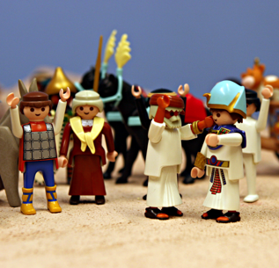


Please read this Bible story with your children. The questions you see below are the same ones we asked them in their small group time this week. We gave you the answers to help you out. Don’t treat this like a test, make it a discussion. Ask more questions and get your children to tell you the story if they can.

Joseph’s Reunion
Genesis 43:1-45:15
Theme: God works all things out for good in my life.

What is your favorite piece of candy in a box of chocolate? caramels What is your least favorite? coconut

In the Bible story, why did Joseph’s brothers go to Egypt? To buy food Did they want to go? No, but they ran out of food and had no choice

How many different kinds of tests can you name? school tests, testing fruit in a store, a race is a kind of test to see who is fastest, testing the water in a bath or shower, tasting food to see if it needs salt and pepper…

Why did Joseph put his cup in Benjamin’s sack? To test his brothers. He wanted to see if they were as jealous of his brother as they were of him.

Why did Joseph want to test his brothers? He didn’t trust them.

What was Joseph afraid his brothers might do if he let them go home? He was afraid that his brothers would go home and not tell their father that Joseph was alive.

Why would his brothers not tell their father about Joseph? When their father heard what they had done to Joseph and how they had lied to him he would be very angry.

Did Joseph’s brothers pass the test? Yes How? Judah offered to stay in Egypt in place of his brother Benjamin.

What is a family reunion? Have you ever been to a family reunion? What is it like?
What do you think Joseph’s reunion was like for Joseph? For his brothers?

Prayer: Thank God that He is always with us and will always work things out for good in my life.
Here’s some strange and unusual facts we came across that we think you might find interesting and entertaining.

The Egyptian hieroglyphic symbol for the word “son” is a duck.

The first Egyptian pyramid built had a 34 ft. wall surrounding it with 15 doors. Only one of the doors opened.

There were no roads in Egypt. Everything moved by boat on the Nile River.

Some Egyptian children had a pet monkey of a gazelle. Cats were considered holy and they wore a gold earring if they were kept in a house.

Egyptians invented the plow.

The New Testament was translated into Egyptian sometime between 100 and 200 A.D.

Egyptians invented the 365 day calendar and the 24 hour day.

Joseph was the bratty little brother they sold into slavery and now he was second in command in all of Egypt. Joseph’s family was starving and he was able to provide food for them and save them from starvation. God does amazing things!
Interesting Facts

