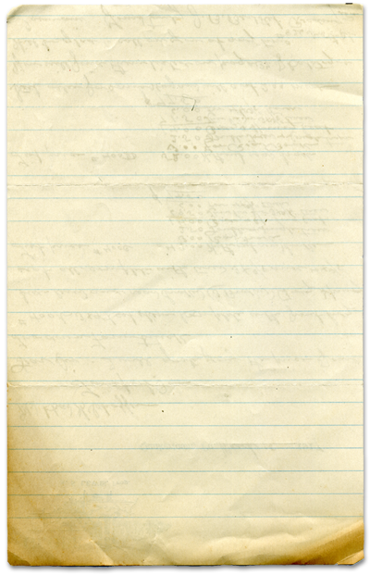

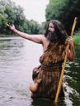

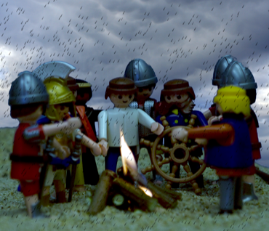
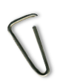


Paul is Bitten by a Snake

God will take care of us

Ouch!
I grew up on a farm so I’m no stranger to animal bites. Goats love to bite but they’re more interested in eating than being mean. Cow’s don’t bite, probably because they’re so dumb. Chickens and geese love to peck at you but that really doesn’t count as a bite. It’s more of a painful poke. Our farm had all kinds of snakes but none of them were poisonous. The snakes did bite but only of you were a mouse, which we had plenty of. We were never really afraid of animals biting us because it was so rare. Most of the time, you could tell when an animal was ready to bite and you’d just back off. Most of the time.
Salt and Pepper were two horses we had on the farm that belonged to my uncle. The thing about Salt and Pepper is that they adored my uncle, but hated everyone else, especially me. I’m not sure why a horse decides it will hate someone but I must have met their criteria.
Salt and Pepper’s favorite thing to do was to lull me into a sense of complacency. They would then trick me into thinking we were friends. Then, when I wasn’t looking, they would bite me really, really hard. I’m convinced that a horse bite is worse than a shark. I cannot tell you how much it hurts. At least when a shark bites, the painful part is severed, right? When a horse bites, the crushed appendage is still a part of you, reminding you it’s crushed.
The Apostle Paul was bit by a viper on the hand. Those around him thought it was God punishing Paul. But God took care of Paul and he didn’t even get sick. The people who accused Paul of something bad knew that Paul’s God was real and that he cared for Paul.
When I was a kid, I often prayed that God would take care of Salt and Pepper (if you know what I mean).
You will find
today’s story in

Acts 28
Take It Home



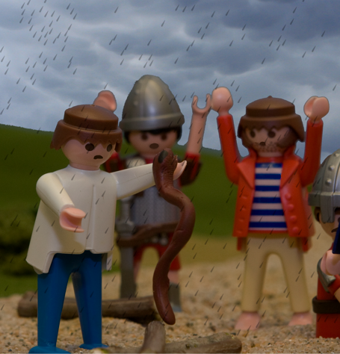

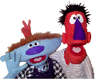
Please read this Bible story with your children. The questions you see below are the same ones we asked them in their small group time this week. We gave you the answers to help you out. Don’t treat this like a test, make it a discussion. Ask more questions and get your children to tell you the story if they can.

Paul is Bitten by a Snake (Acts 28)

Why did Paul get bitten by a snake? He was gathering wood. Why was Paul gathering wood? He was cold and wet.

Why was Paul cold and wet? He was shipwrecked on an island. Why did Paul’s ship run aground on the island? There was a storm. Why was Paul on a ship? He was going to Rome. Why was Paul going to Rome? He was a prisoner going to trial in Caesar’s court. Why was Paul going to trial? He was falsely accused of causing trouble in Jerusalem

How do you think Paul felt when he was bit by the snake? Bad. Do you think it hurt Paul when he was bitten by the snake? Yes How would you feel if the same thing happened to you? If you were on that beach, would you think that was God happy with you, or would you think that God was mad at you and punishing you?

Read Romans 8:28a (page 1463 in the Kids’ Quest Bible) “We know that in all things God works for the good of those who love Him.”

Was it good that Paul was a prisoner? No. Was it good that Paul was in a storm? No. Was it good that Paul was cold and wet? No. Was it good that Paul was hungry and tired? No Was it good that Paul was bitten by a snake? No

What did the people of the island think when they saw that Paul did not die after being bitten by the snake? They thought that Paul’s God was very powerful and they wanted to know more about Paul and Jesus. What did they do? They invited Paul into their homes and Paul told them all about Jesus. Was that a good thing? Yes it was!

What are some bad things that can happen in your life? Sickness, accidents, losing something you own, getting lost Can bad things happen to you? Yes Does this mean God doesn’t love you or He is punishing you? No. God always loves you and wants the best for you. If bad things happen God will help you through those times and use them to make good things happen in your life.

Prayer: Thank God for always being with us and ask Him to help us through bad times and to remember that he will work everything out for our good.
Here’s some strange and unusual facts we came across that we think you might find interesting and entertaining.

The jaws of the snakes are not fused together. That means that unlike our jaws, snakes jaws are not hooked up at the back of their mouths. This makes it possible for them to eat very big meals, bigger than their own heads! That would be like you swallowing a whole watermelon!
If you had your mouth full of a watermelon, do you think you could breathe? Not likely! Snakes can. They have a little tube at the bottom of their mouth that comes out far enough to get air when the rest of their mouth is full.
Some snakes can smell with their noses but ALL snakes smell with their tongues. When a snake sticks out its tongue it smells its surroundings. The moist tongue collects scents and small organisms from whatever it touches and from the air around it. When the tongue goes back into the mouth the forks touch a special sensory spot called the Jacobson's organ on the roof of the mouth and tells the snake what it smells. Snakes have a small notch in their lips that they can stick their tongues through so they don’t need to open their mouths.
While shipwrecked, Paul laid some sticks on a fire. When he did this, a snake crawled out of the sticks and bit him on the hand. But God took care of Paul.
Interesting Facts

