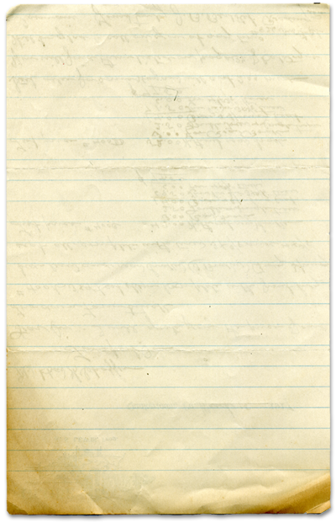


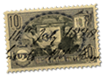
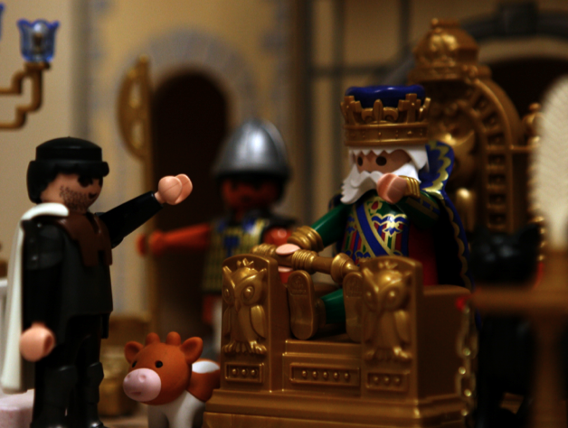



Mordecai is Honored, Haman is Shamed

God honors the humble

Getting what he deserved
How many times have you had something bad done to you while on the road? And how many times have you said to yourself, “Where’s a cop when you need one?”
Several years ago I was driving home from the city. Traffic in Petaluma was at a standstill and everyone was tense. We all just wanted to get home. I hopped off the freeway and took Stony Point Road along with several others who knew the back roads. The road had a double yellow line down the middle indicating it was a “no passing” zone. That did not seem to bother a young man in a new Mustang. I could see in my rearview mirror he kept passing car after car, narrowly avoiding several head-on collisions. He made his way up to me and started to pass when suddenly, over the hill, came a CHP cruiser. The young man swerved into me forcing me to slam on my brakes. He knew he was in trouble.
Several yards ahead he quickly turned off Stony Point. I knew the CHP officer would not see where he went so I stopped at the intersection and waved to the officer which direction this Mustang headed. I got a quick salute and the officer caught the young man. Just at the moment I thought, “Where’s a cop when you need one,” a CHP cruiser appeared over the hill. I was elated and relieved. The young man was scared so he ran, evading an officer. He got what he deserved.
In this week’s Bible story, Haman is busted. Queen Esther reveals Haman’s evil plan to kill the Jews to the King. The King is shocked his trusted advisor would plot to destroy his Queen and the man who saved his life.
This week we learn there are consequences for bad behavior. Sometimes we get what we deserve.
You will find today’s story in

Esther 5-6
Take It Home


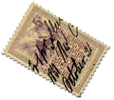
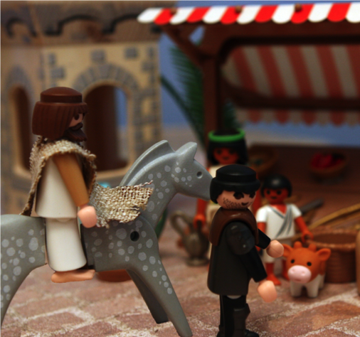


Please read this Bible story with your children. The questions you see below are the same ones we asked them in their small group time this week. We gave you the answers to help you out. Don’t treat this like a test, make it a discussion. Ask more questions and get your children to tell you the story if they can.

Do you get mail often? Have you ever gotten a package in the mail? Do you like getting mail?

In the Bible Story, why was Haman angry with Mordecai? Because Mordecai would not bow down and worship Haman.

What did Haman build for Mordecai? A gallows 75 feet high.

Haman was at the palace to ask the king’s permission to hang Mordecai but what happened? The king wanted to honor Mordecai so Haman had to parade Mordecai around the city on a horse and the king’s fine clothes.

Why did the King want to honor Mordecai? Mordecai had overheard two of the king’s servants plotting to kill the king. Mordecai informed the king and the two were arrested. Mordecai saved the king’s life.
How did God protect Mordecai? God did not let the king sleep that night so the king had time to read the story where Mordecai saves the king’s life so the king chose to honor (reward) Mordecai rather than listen to Haman.

What would have happened to Mordecai if the King had fallen asleep that night? The king would have let Haman send Mordecai to the gallows.

Did you feel sorry for Haman when you heard he had to honor Mordecai by leading him around the city? No. Why not? Because he got what he deserved.
Was Haman proud? Yes What does it mean to be proud? To think only of yourself and want others to think only of you too.

What does it mean to be humble? to think of others first. How do you know Mordecai was humble? Mordecai didn’t demand any reward for saving the king’s life.

Prayer: Thank God that He is just and fair. Thank God that He loves and honors those who are humble. Ask God to help us treat others the way we want to be treated by them.
Here are some more bizarre and random trivia facts. We know they are a little strange but they are interesting.

-The average American eats 58 quarts of popcorn each year.
-Popcorn pops because of water.
-The ideal popping temperature is between 400 and 460 degrees.
-One cup of oil popped popcorn has 48 calories.
-Anthropologists found popcorn ears in the bat caves in New mexico that were 5,600 years old.
-The top three popcorn producing states are Nebraska, Illinois, and Indiana
-The ideal place to store popcorn is in a cool, dry cupboard.
-There are 1,600 popcorn kernels in one cup.
-When popping popcorn on the stovetop it is best to use vegetable oil.
-According to the Guinness Book of World Records, the world’s largest popcorn ball weighed 2,000 pounds.
-Nearly all the popcorn in the world (97%) is produced in the United States.
-The folks in the five Midwestern states eat more popcorn annually than the rest of the world’s population combined.
Haman did everything the king said to honor Mordecai. He even led him around the city and had to shout to all the people that this is how the king wanted to honor Mordecai.
Interesting Facts

