



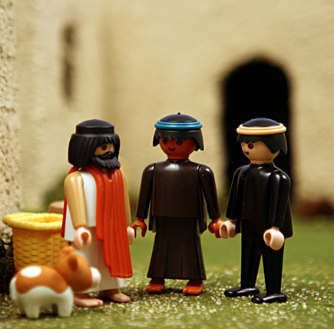



I can tell others about Jesus!

Jesus’ first disciples

What would YOU do?
In recent years the Christian church has been beset by fads. Do any of these ring a bell? Prayer of Jabez, the Left Behind series, Weigh Down Workshop, Promise Keepers, WWJD and the king of all fads, 40 Days of...
Every fad has a life cycle. It’s first accepted, then embraced, and finally abandoned. Some fads have a built in expiration, others just slowly fade away. In Ephesians, Paul writes, “We are no longer to be children, tossed here and there by waves, and carried about by every wind of doctrine.” Then he says “...but speaking the truth in love we are to grow up in all aspects unto Him, who is the head, even Christ.”
In today’s Bible story we learn that Jesus is more than a fad. Time alone has proven that to be true. But the way in which many are drawn to learn more about him tends to become the object of worship, rather than the Christ. The church is supposed to be steadfast against these whims. Paul was speaking to the church, not the world. But we tend to embrace these fads fully just because they’re “Christian.”
When Jesus called his disciples to follow him, they dropped everything and made a life-long commitment. They never wore WWJD bracelets and they never registered for Promise Keepers. They were sold out on Christ (for more than 40 days).

You will find today’s story in

John

1:35-51
Take It Home


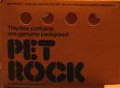




Please read this Bible story with your children. The questions you see below are the same ones we asked them in their small group time this week. We gave you the answers to help you out. Don’t treat this like a test, but make it a discussion. Ask more questions and get your children to tell you the story if they can.

Jesus’ First Disciples
John 1:35-51
I can tell others about Jesus.

What was Ole trying to do today? Keep a secret Did he do a good job? No

What was Ole’s secret? That anyone who follows Jesus will go to heaven and live forever with Him.

Was Ole’s secret a real secret? No Why not? God wants everyone to know about Jesus

Are secrets bad? No. Sometimes secrets are bad and sometimes they are good. If your friend has an embarrassing story and doesn’t want anybody else to know, that can be a good secret.

When is it a bad thing to keep a secret? When somebody has done something wrong and they tell you it needs to be a secret.

When is it a good thing to tell a secret? When it prevents someone from getting hurt.

In the Bible story, what did Andrew and Philip do when they started to follow Jesus? They told their friends about Jesus. Andrew told his brother Peter and Philip told his friend Nathanael.

Why did Andrew and Philip tell their friends about Jesus? They knew Jesus was special and they wanted others to know too.

What is a good way to let others know about Jesus? Invite them to church. You can tell people about Jesus by the things that you do. (Being kind, generous, patient, sharing with others can also tell others about Jesus)

What can you do to tell others about Jesus? You can invite friends to church. You can tell your friends about how God answers prayers and then pray for your friends. You can tell people about Jesus by the things that you do. (Being kind, generous, patient, sharing with others can also tell others about Jesus)
Can you think of a friend you want to tell about Jesus?

Prayer: Ask God to help us tell others about Jesus so they can know Jesus too.
In the 1970’s. One of the strangest fads ever to appear happened all across America. A man in the Bay Area decided to sell pet rocks. The first pet rocks were ordinary building stones bought at a builder’s supply store. The fad lasted for six months ending with the Christmas season in 1975. During it’s short run the pet rocks made their creator a millionaire. He sold the rocks for $3.95 each. They were nestled in a cardboard pet carrier and had googly eyes glued onto them. A “Pet Rock Training Manual” instructed the new owner on how to feed the rock and take it for walks. It also taught you how to teach your rocks tricks like, “play dead,” “sit,” and “roll over.” You can make your own pet rock at home. Give it a name and see if you can teach it any tricks.
Interesting Facts

