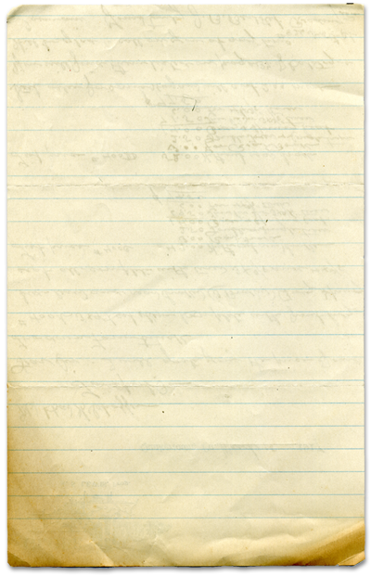
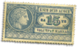
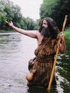
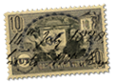
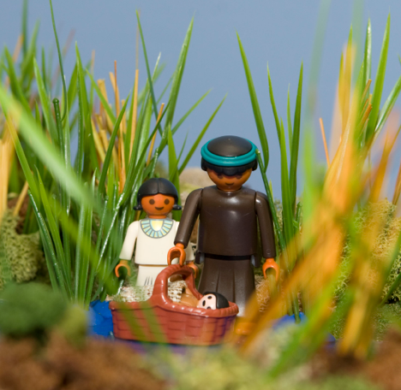
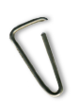


The Baby in a Basket

God has a special plan for my life

PAINTBALL
The first time (and last time) I played paintball was at Mare Island. I had no idea what I was doing. Our team got our rental guns. Immediately we noticed that there were people there who thought they were Navy Seals. They had their own guns with giant tanks of who-know-what in them. They looked and acted like this was a war to the death. They were all wearing camouflage. We were all in jeans and hooded sweatshirts.
The game began and we knew we were toast, just like the folks wearing red shirts in Star Trek. But, I had a trick up my sleeve. I learned from my hunting days on the farm that if I stayed perfectly still, I could hide in plain site from passing animals. And these guys were animals. A group of us did just that.
Soon, a team of wanna-be commandos walked right up to us in our street gear and none of them saw us. They were only 10 feet away from us when we opened fire. We took out all of them. Imagine the humiliation. We had rental guns and hoodies. They were outfitted to win World War III.
Baby Moses was in great danger from the Pharaoh. God had a special plan for Moses’ life and his mother knew it. So Moses was hid in plain sight from Pharaoh for many years. Moses not only was hidden in a basket, he was then “hidden” in Pharaoh’s court. God’s special plan for Moses’ life would happen, and it would be amazing.
After we shot the commandos, they opened fire on us, illegally, and we reported them all and they were ejected from the game. The good guys won.
You will find
today’s story in

Exodus 1:1 - 2:10
Take It Home


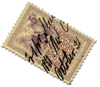
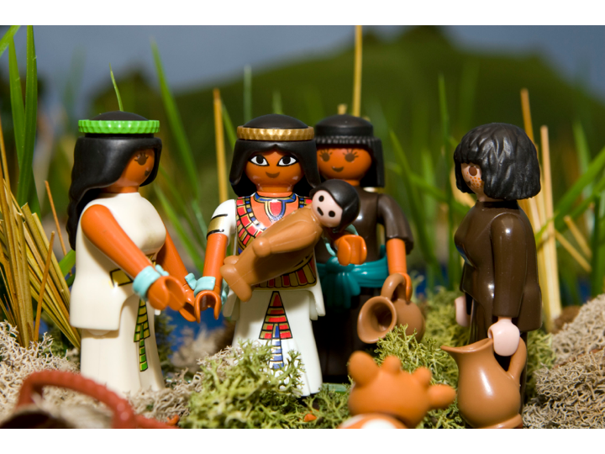


Please read this Bible story with your children. The questions you see below are the same ones we asked them in their small group time this week. We gave you the answers to help you out. Don’t treat this like a test, make it a discussion. Ask more questions and get your children to tell you the story if they can.

The Baby in a Basket
(Exodus 1:1-2:10)

What was Sven afraid of? He was afraid that all of his toys would get ruined.

Who was coming over to visit? The Pappenfous’s

What did Sven decide to do? Bury his baseball card collection.

Did Sven’s plan work? No Why not? Ole forgot where he buried Sven’s cards

Have you played hide and go seek? Is it fun? What is the best hiding place you have found?

Why did Moses’ mom hide Moses? She didn’t want the soldiers to find her baby. What would have happened to Moses if he had been found? The soldiers would have killed Moses.

What did Moses’ mom do when she could no longer hide Moses? She put him in a basket and hid him in the river
What happened then? The princess saw the basket and found Moses. She decided to keep the baby so Moses was safe.

Do you think God was watching over Moses? Yes How can you tell? God kept him safe through all the dangers (the soldiers didn’t find him, he didn’t get carried away by the river, a princess found him, she liked him and decided to keep him)

Why did God save Moses? God had a plan for Moses’ life. Moses was going to be a great leader of the nation of Israel.

Do you think that God has a plan for you? Yes Do you think that God is watching over you? Yes How can you tell?

Prayer: Thank God that He loves us, watches over us and has good plans for our lives.
Here’s some strange and unusual facts we came across that we think you might find interesting and entertaining.

When Albert Einstein died, his final words died with him. The nurse at his side didn't understand German.
St Patrick, the patron saint of Ireland, was not Irish.
Many sailors used to wear gold earrings so that they could afford a proper burial when they died.
A South African monkey was once awarded a medal and promoted to the rank of corporal during World War I.
The Toltecs, Seventh-century native Mexicans, went into battle with wooden swords so as not to kill their enemies.
The Amayra guides of Bolivia are said to be able to keep pace with a trotting horse for a distance of 100 kilometres.
Sliced bread was patented by a jeweler, Otto Rohwedder, in 1928. He had been working on it for 16 years, having started in 1912.
Pharaoh’s daughter liked the baby boy and decided to keep him as her own baby. She named him Moses which means “drawn from the water.”
Interesting Facts

