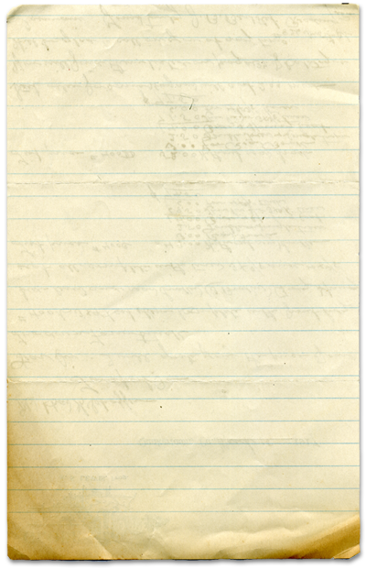

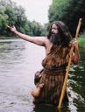

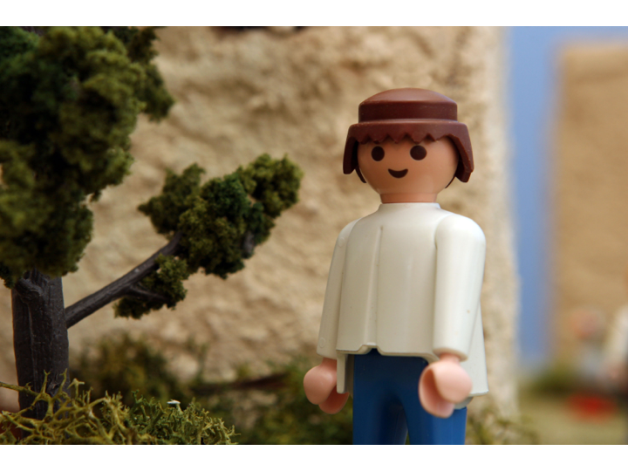



Paul Meets Jesus

A changed man

THe Third world
Way back in 1979 I was invited with a large group of students to visit the Dominican Republic to do some construction and relief work following the devastating Hurricane David. The hurricane hit the country with it’s full fury and devastated the already desperately poor country.
I grew up on a farm in a small town in Minnesota where most of life went by with very few troubles. Everyone had warm homes, and education, cars, and no one went hungry. So imagine the shock when I stepped out of that plane and was bussed into the city of Santa Domingo. I had never seen or imagined poverty like I was witnessing outside that bus window.
We stayed in an abandoned palace of the former president of the country. It too was destroyed by the hurricane but it provided us with a roof over our heads and some semblance of security. We spent our days rebuilding roofs and constructing small wooden shacks for people who were living out of cardboard houses covered in plastic sheeting. What seemed humble to us was palatial to the people we were serving.
Today we talked about a man named Saul who did not like followers of Jesus. In fact, he was downright hostile to them. One day as he was traveling he was struck down by a bright light on the road. Jesus appeared to Saul and Saul had an amazing experience that would change his life forever.
One day as we were eating in our compound a group of starving children snuck through the gate and found us eating and begged for food. We were cautioned not to feed them for fear of a riot and the children were chased away. Later that day we found them and snuck them our food and clothing. It was an event that forever changed me. I had never been confronted with something so unbelievable and desperate. I would never forget it. I was changed.
You will find
today’s story in

Acts 9:1-9
Take It Home



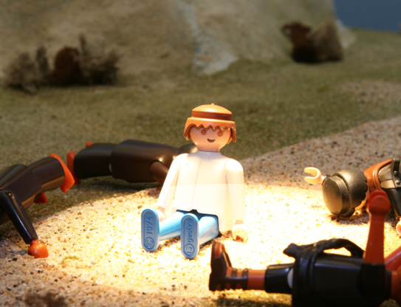


Please read this Bible story with your children. The questions you see below are the same ones we asked them in their small group time this week. We gave you the answers to help you out. Don’t treat this like a test, make it a discussion. Ask more questions and get your children to tell you the story if they can.

Paul Meets Jesus
(Acts 9:1-9)

What game did Ole and Meep play? Saturn’s rings Why was Meep mad? He lost What did Ole win? Meep’s pet

What happened to the egg that Ole got from Meep? It broke open three times and changed into bigger and bigger animals.

What is it called when an animal changes from one kind to another like the pet that Ole got from Meep? Metamorphosis

What real animals do this? Moths, butterflies, beetles

Can people metamorphose? Not physically. But people can change. Jesus tells us that when we commit our lives to God, God changes us. He makes our spirits alive inside of us and we become a new person. Jesus says its just like being born for a second time or born again. (John 3:1-21 Page 1371 in the Kids’ Quest Bible)

Who in the bible story was changed? Paul the Apostle

What was Paul the Apostle like before he met Jesus on the road to Damascus? He was mean to Christians and had them arrested and thrown into prison.

What happened to Paul when he met Jesus? He was blinded by a light from heaven and fell off his horse. Then he talked with Jesus

Was Paul mean after he met Jesus? No What did Paul do after he got better? Paul told everyone he met about Jesus and he began to help others learn about Jesus too.

Prayer: Thank God for choosing us to be a part of His family. Ask God to help us be like Paul the Apostle and help others to know Jesus.
Here’s some great little jokes you can share with your friends or your folks.

Q. What did the glue say to the teacher?
A. "I'm stuck on you."
Q. Why did the clock in the cafeteria always run slow?
A. Every lunch it went back four seconds!
Q. Why was the music teacher not able to open his class room?
A. Because his keys were on the piano.
Q. What do you do if a teacher rolls her eyes at you?
A. Pick them up and roll them back to her!
Q. Why are school cafeteria workers cruel?
A. Because they batter fish, beat eggs, and whip cream.
Q. What flies around the kindergarten room at night?
A. The alpha-BAT.
Q. Why doesn't the sun go to college?
A. Because it has a million degrees!
Suddenly a bright light flashed around him. Saul fell to the ground. A loud voice asked, “Saul, why are against me?”
Interesting Facts

