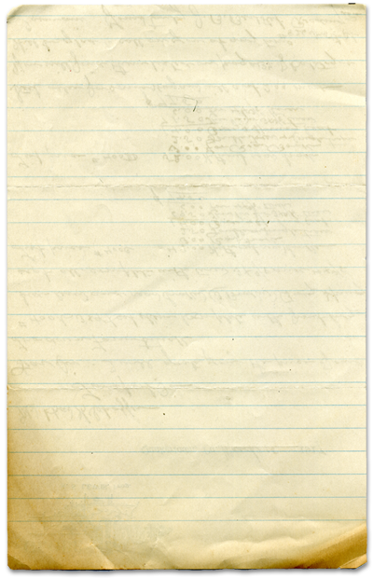

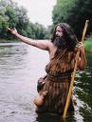

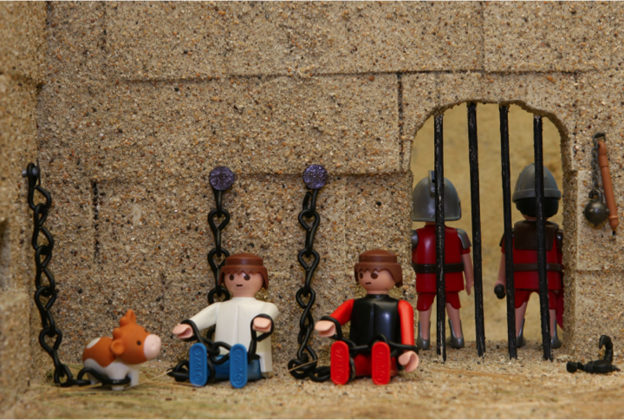



Paul & Silas go to Prison

God will take care of us

Ole the viking in alexandria, minnesota
When I was 19 I went to the second Indiana Jones movie in a small Minnesota town called Alexandria. The town of Alexandria is well known in Minnesota as the place where the Kensington Rhunestone was found. It’s a 1,000 year old stone with Viking carvings on it. But many people think it’s a fake. To celebrate the stone (real or not) the town constructed a giant thirty foot tall statue named Ole the Viking.
When we left the theater we saw Ole the Viking at the end of the boulevard. We rushed into our car to see it. Still dressed as Indiana Jones, my friend Dean quickly exited the car and climbed Ole’s gigantic spear.
Minutes later a police officer raced to the scene, got out of his car, and drew his gun because he saw Dean’s fake gun strapped to his side. The story is much funnier when told in person. We spent the next two hours being interrogated by several police officers as to what we were really doing in town. Thankfully, all our stories matched and they gave us a five squad car escort out to the city limits.
That was the closest I had ever been to going to jail. At one point it looked like they were going to even handcuff all of us. We were scared but it was all so funny it was hard not to laugh. I think even the police officers thought it was funny but they had to do their job. It would not have been so bad were it not for Dean’s fake gun.
If we did go to jail, it would have been because we were rascals. Paul and Silas were arrested for what they believed and preached, not for something bad they did. God took care of Paul and Silas by sending an earthquake. They could have escaped but they stayed to minister to the jailer and eventually led him to Jesus and baptized him and his entire family. God took care of Paul and Silas. He’ll take care of you. However, if you ever climb the spear of Ole the Viking, you’re on your own :-).
You will find
today’s story in

Acts 16:16-24
Take It Home



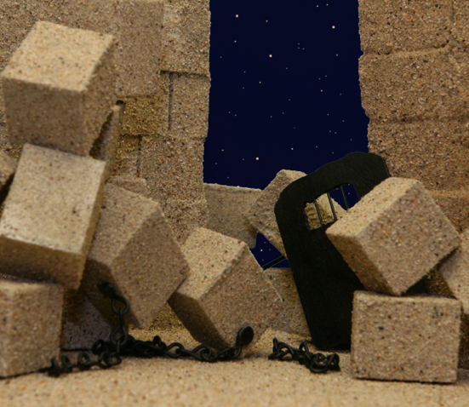


Please read this Bible story with your children. The questions you see below are the same ones we asked them in their small group time this week. We gave you the answers to help you out. Don’t treat this like a test, make it a discussion. Ask more questions and get your children to tell you the story if they can.

Paul and Silas go to Prison
(Acts 16:16-24)

What was Ole’s surprise today? He got a new pair of Heelys. What was Sven’s surprise? He was watching Fluffy for Grandma and wanted Ole to help

Why did Sven want to watch Fluffy for Grandma? To earn some money. What happens every time Ole and Sven watch Fluffy? They get in trouble.

What happened this time? Sven was thrown in jail.

Did Sven steal the lady’s purse? No Why did he get arrested? The lady accused Sven of stealing her purse after Sven picked it up.

Who was the Bible story about today? Paul and Silas.

What did Paul and Silas do when they got in trouble? They helped a woman who was a fortuneteller and she stopped telling people’s fortunes. Was that a bad thing? No, it was a good thing

Why were the people mad at Paul and Silas? Because the people the lady worked for wouldn’t make money anymore after Paul and Silas helped her.

What did they do to Paul and Silas? They whipped them and threw them in jail. Was that fair? No.

What did Paul and Silas do in prison? They prayed and sang hymns.

Did God take care of them? Yes What happened? God sent an earthquake that set them free.

What happened after the earthquake that helped Paul and Silas? The Phillipean jailer was so impressed he took Paul and Silas home and bandaged their wounds. He listened to Paul and he and his whole family were baptized.

Have you ever gotten into trouble for trying to do something good or for trying to help someone?
When that happens what should you do? You should trust that God will take care of you.

Prayer: Ask God to help us help others and thank God that He will always take care of us.
Here’s some strange and unusual facts we came across that we think you might find interesting and entertaining.

The largest recorded earthquake in the United States was a magnitude 9.2 that struck Prince William Sound, Alaska on Good Friday, March 28, 1964.

The largest recorded earthquake in the world was a magnitude 9.5 in Chile on May 22, 1960.

The earliest reported earthquake in California was felt in 1769 by the exploring expedition of Gaspar de Portola while the group was camping about 30 miles southeast of Los Angeles.

Moonquakes ("earthquakes" on the moon) do occur, but they happen less frequently and have smaller magnitudes than earthquakes on the Earth. It appears they are related to the tidal stresses associated with the varying distance between the Earth and Moon. They also occur at great depth, about halfway between the surface and the center of the moon.

The hypocenter of an earthquake is the location beneath the earth's surface where the rupture of the fault begins. The epicenter of an earthquake is the location directly above the hypocenter on the surface of the earth.

It is estimated that there are 500,000 detectable earthquakes in the world each year. 100,000 of those can be felt, and 100 of them cause damage.

That night God sent an earthquake. It shook so hard that all the prison doors opened up and all the prisoners’ chains fell off.
Interesting Facts

